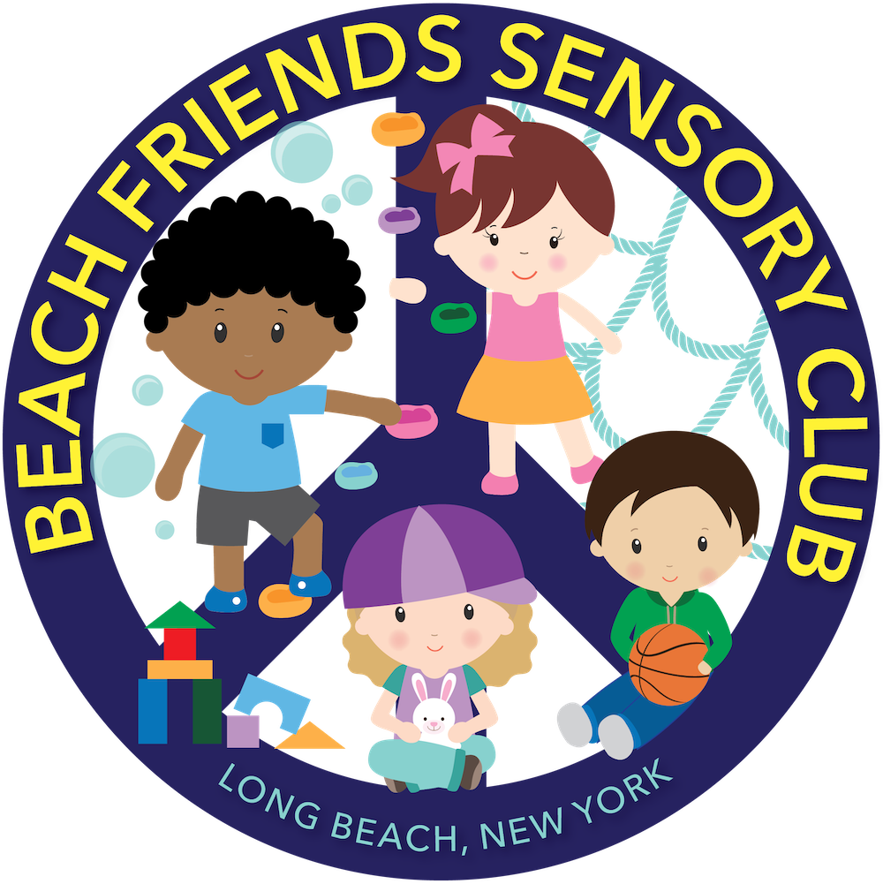

Beach Friends Pre-Registration Form

Name: _______________________________ Date: ___________________________

Beach Friends Registration Check List

CHILD INFORMATION:

Child’s full name: ___________________________________

Child’s DOB: _____/_____ /_____

Child’s Gender: Male___ Female ___

Enrollment Date (today’s date): _____/_____ /_____

Start Date (first date child will attend class): _____/_____ /_____

Classroom: Nursery _________ Preschool ________

Schedule (please write times next to each day your child will be attending): 8am-12pm OR 9am-12pm
Monday: Tuesday: Wednesday: Thursday Friday: ____

Time: _______________________________________________________

PARENT INFORMATION

Parent’s full name: __________________________________________________

Parent’s email address: @ _______ .com

Parent’s Address:
__________________________________________________________________________

__________________________________________________________________________

Parent’s Phone number: ( ) _____-______
Daily Rate: $ ____________ ￼
2 Week Security Deposit Amount: $ ___________
Registration Fee: $75.00
Total Amount Due: $________________

Payment method: Check Cash___

Payment date: _____/_____ /_____

X________________________________________
(admin signature)

PLEASE DO NOT CHECK BOXES_ ADMIN ONLY
Beach Friends
- Emergency Procedure Acknowledgment/Sick Policy/No medication/Release number___
- Diaper Prep Consent/Photo Consent/Food consent _____
- Feeding Schedule_____ (6 weeks (about 1 and a half months)-18months)
- Napping Agreement_____
- Schedule/Payment Agreement/Signatures of received documents____
- Child Profile______
- COVID-19 policies for daycare_______
- Medical consents
0792 Emergency blue card_________
6010 Non-Medication Consent____
4433 Child in Care Medical statement___(one time a year)
____________________________________________________________________________

Specific requirements
7006(Health plan) (also child with a therapist) _____
5014 (therapist consent) _____
6029 (Allergy/Anaphylaxis emergency plan) _____ (one time a year)
7002 (Medication consent form) ______ (every six months)
Benadryl (no yellow bar)
7004 (if parent wants to come in to administer medication)
_____________________________________________________________________________

- Copy of Handbook/HCP______
- Information of lead screening___
- Registration fee_____
- Security Deposit_____
- Supplies______

Start Date____________

Birthday______________

End Date_____________

Medical due___________
Medical Due___________
Medical Due___________
Medical Due___________

Emergency Procedures Acknowledgement

I understand Beach Friends will respond appropriately when dealing with injuries that occur while in the daycare. I agree that I will not hold Beach Friends responsible or any staff responsible in case of accidental injuries that occur during play activities in which children might engage in. If Beach Friends cannot contact parents and/or emergency persons listed on the Emergency and Release Persons Form, I hereby give permission to Beach Friends to secure the proper treatment for the child in a hospital given licensed and trained staff as needed. *If a child becomes injured, parents will be notified at once. An accident report will be written up and signed by staff. *
___________________________________ (Parent Signature) _____________________________________ (Date)
Sick Policy
Beach Friends will only allow well children in their program. Well children are non-sick children who have no symptoms of any minor childhood illness and that do not stand for a risk to other children. If a child becomes sick, a doctor note is needed to return to Beach Friends.
_________________________________ (Parent Signature) _____________________________________ (Date)
No Medication Policy
Absolutely no medications can be administered by the staff at Beach Friends. I understand that I will be notified shall my child become ill during the day, and I will pick up my child promptly or decide for an authorized emergency contact/release person to pick up my child upon such notification.
If my child is exposed to or contracts a contagious disease, I agree to let Beach Friends know and I understand that my child will be readmitted once cleared by a doctor provided with a doctor’s note.
Release of Phone Number/E-Mail Address
Beach Friends will send out a class list. Please consent to have your phone number and/or e-mail address released amongst families for play dates, birthday parties, etc.
____I consent
____I do not consent
phone number_____________________________ e-mail address ___________________________________
____________________________________
(Parent signature)
__________________________________(Date)
Diaper Change Consent/External Preparations Consent
I hereby grant permission that Beach Friends provider and staff can provide care by cleaning and changing my child as needed.
X____________________________ (Parent’s signature/Date)
I hereby give Beach Friends the permission to apply one or more of the following external preparations following the directions for use on the container; Baby wipes, Bandages, Neosporin, Hydrocortisone, Bacitracin or similar first Aid Sprays, Non-Prescription Ointments such as A and D and sunscreens.
(non-medical consent form for each topical cream will be given)
Absolutely no medications can be administered by Beach Friends and its staff. I understand that I will be notified shall my child become ill during the day, and I will pick up my child promptly or decide for an authorized emergency contact/release person to pick up my child upon such notification.
If my child is exposed to or contracts a contagious disease, I agree to let Beach know Beach Friends and I understand that my child will be readmitted once cleared by a doctor provided with a doctor’s note.
X____________________________ (Parent’s signature/Date)
PHOTO CONSENT

I HEREBY CONSENT TO GIVE PERMISSION TO BEACH FRIENDS TO PHOTOGRAPH, FILM OR VIDEOTAPE MY CHILD________________________.
WHILE AT THE DAYCARE FOR EDUCATIONAL PURPOSES AND COMMUNICATION BETWEEN PARENTS AND STAFF.

X____________________________________
(Parent’s signature/Date)
FOOD CONSENT
I consent to allow my child to take part in cooking classes, birthday parties and consume foods outside of packed lunches.
X____________________________________________
(Parent’s signature)
EPIPEN
- Staff who have been instructed on the use of the epinephrine auto-injector, diphenhydramine, asthma medication or nebulizer must be present during all hours the child with the potential emergency condition is in care and must be listed on the child’s Individual Health Care Plan.
- The staff administering the epinephrine auto-injector, diphenhydramine, asthma medication or nebulizer must be at least 18-years old, unless the administrator is the parent of the child.
- Staff must at once contact 911 after administering epinephrine.
- If an inhaler or nebulizer for asthma is administered, staff must call 911 if the child’s breathing does not return to normal after its use.
- Storage, documentation of administration of medication and labeling of the epinephrine auto-injector, asthma inhaler and asthma nebulizer must follow all proper regulations.
My child __________________________ will keep an epinephrine auto-injector at the facility
X____________________________________________________
(Parent’s signature/Date)

Infant Feeding ONLY (Schedule and Parent Agreement) 6 weeks (about 1 and a half months)-18 months (about 1 and a half years)
- All Bottles, cups and utensils must be labeled with child’s full name. Powered formula, ready to feed milk, juice and breast milk must be pre-measured and labeled with child’s first and last name and end date.
- Children 6 months of age and under must be held during all bottle feedings.
- Microwave heating of infant food and formula is prohibited by regulation.
- The provider will make every effort to accommodate the needs of a child who is breast fed.

Infants’ Name: _______________________
Date of Birth: _______________________

___I will provide all formula, solid food, water, and juice for my child.
Check all that apply:
___Breast Milk
___Formula-Brand________________
___Solid Foods

List of any food allergies: ______________________________________________

Please first:
___I give the provider permission to add warm sterilized water to powered formula.
___I give the provider permission to warm milk in a bottle warmer.
___I give the provider permission to warm solid food.
Please feed my infant according to the following schedule:
Signature of Guardian: ____________________ Date: _________________________
Signature of Provider: _____________________________ Date: _____________________
NAPTIME ARRANGEMENTS
I understand that my child, ___________________________________ will sleep on a
___COT___ MAT___ CRIB___ PORTABLE CRIB___ BED___ BASSINET
All doors to the sleeping/napping area will remain open always. If the provider is not in the same room as the children when they are sleeping, a functioning electronic monitor will be used with written parental permission. If an electronic monitor will be used, the provider will physically check on my child every 15 minutes.
_____I will______ I will NOT allow my child to sleep with the provider in another room as the children with a functioning electronic monitor. The provider will always remain on the same floor as my child.

Signature of Parent/Guardian: ______________________________ Date: ________________

Signature of Provider: _________________________________ Date: _________________

SUPERVISION OF SCHOOL AGE CHILDREN
I give permission for my school aged child, ______________________________________ to sometimes take part in activities out of the direct supervision of the caregiver. Such activities will occur on the premises of the day care home. A caregiver will visually check my child every 15 minutes.
My child can use the toilet independently; therefore he/she will use bathroom for short periods of time without direct visual supervision.
Signature of Parent/Guardian: _________________________ Date: ______________________
Signature of Provider: _______________________________ Date: _______________________
Please read the contract in its entirety
BEACH FRIENDS
SCHEDULE AGREEMENT
SECURITY DEPOSIT: __________________ (2 weeks) AMOUNT: ______________Paid on:___________VIA:________
REGISTRATION FEE: _________Paid on:___________VIA:________
START DATE: ______
It is hereby between______________ (Parent’s name) and Beach Friends that the following schedule will be available for _______________ (Child’s name) starting on ________ (Date). Calculation: I agree that I am responsible in the payment of the amount of $_____ a day X how many days are in a month. The monetary amount per month is calculated by the amount per day X the number of days per month. (variable rate)
Monday_______ Time: ______
Tuesday_______ Time: ______
Wednesday____ Time: ______
Thursday______ Time: _______
Friday________ Time: _______
X_____________________________ (Parent’s signature/date)
PAYMENT AGREEMENT
I AGREE TO PAY A ONE TIME REGISTRATION, NON-REFUNDABLE FEE OF $75.00.
I AGREE THAT THE REGISTRATION FEE OF $75.00 WILL BE PAID IN FULL BEFORE ENROLLMENT. NOTE: THIS IS A ONE TIME FEE ONLY.
I AGREE TO PAY A 2 WEEK SECURITY DEPOSIT (2 WEEKS PAYMENT OF SCHEDULED DAYS) OF $ ______. ____ TO ENROLL MY CHILD. THE SECURITY DEPOSIT WILL BE RETURED ONCE MY CHILD IS NO LONGER ENROLLED OR USED TOWARDS MY LAST TWO WEEK OF CARE.
I AGREE TO PAY THE DAILY RATE OF $ _________. THE MONTHLY PAYMENT IS DUE 1 DAY BEFORE THE 1ST OF EVERY MONTH. (variable rate)
I AGREE CARE IS GIVEN AND PAID ON A MONTH-TO-MONTH BASIS. I AGREE I WILL NOT LEAVE IN THE MIDDLE OF THE MONTH AND/OR BEFORE OR AFTER HOLIDAY BREAKS/SCHOOL VACATIONS/PERSONAL VACATIONS AND/OR SICKNESS. I AGREE I WILL BE RESPONSIBLE TO PAY A FULL MONTH.
I AGREE TO PAY THIS AMOUNT IN FULL REGARDLESS OF PERSONAL VACATION TIME, SCHOOL VACATION TIME, OCCASIONAL SICKNESS OR ANY OTHER REASON, SUCH AS A NATURAL DIASTER/ACTS OF GOD, STATE LOCK DOWN, PUBLIC HEALTH EMERGENCY, COVID-19 RELATED CLOSURES, SNOW DAYS OR ANY OTHER UNFORSEEN CIRCUMSTANCES. I UNDERSTAND NO ALLOWANCES, CREDITS, REFUNDS, MAKEUPS SHALL BE MADE FOR OCCASIONAL ABSENCES.
I AGREE A LATE FEE OF $20.00 WILL BE CHARGED IF PAYMENT IS NOT RECEIVED, FOR EACH DAY UNPAID. I AGREE AND UNDERSTAND THAT IF MY ACCOUNT IS DELIQUENT FOR MORE THAN 2 WEEKS, I MAY BE ASKED TO WITHDRAW MY CHILD UNTIL THE ACCOUNT IS MADE CURRENT.
I AGREEE THAT MY CHILD’S SPOT MAY OR MAY NOT BE HELD WHEN A CHILD IS WITHDRAWN. I AGREE MY CHILD WILL NOT BE ABLE TO RE-ENROLL IF A 2 WEEK NOTICE WAS NOT GIVEN OR IF MY ACCOUNT IS NOT CURRENT. I AGREE THAT ANY UNPAID FEES MAY BE SENT TO A THIRD-PARTY COLLECTION AGENCY. I AGREE MY SECURITY DEPOSIT WILL BE HELD IF TERMS ARE NOT FOLLOWED.
I AGREE TO PAY A $35.00 SERVICE FEE FOR ALL CHECKS RETURNED BY THE BANK.
I AGREE THAT IF I PICK UP MY CHILD AFTER SCHEDULED CLOSING, I WILL BE CHARGED A LATE FEE OF $1.00 PER MINUTE THAT I AM LATE, UNTIL MY CHILD IS PICKED UP.
I UNDERSTAND THAT IF MY CHILD ATTENDS FULL TIME, A TEN PERCENT DISCOUNT IS OFFERED FOR EACH ADDITIONAL CHILD FROM THE IMMEDIATE FAMILY.
I UNDERSTAND THAT I MUST PROVIDE A 2 WEEK WRITTEN NOTICE OF WITHDRAWAL OR CHANGE OF SCHEDULE/CHANGE OF CONTRACT ALONG WITH 2 WEEKS PAYMENT FOR SCHEDULED DAYS FOR THE TWO WEEKS. I UNDERSTAND THE DIRECTOR WILL PROVIDE A 2 WEEK DEPARTURE NOTICE AFTER THE TWO WEEKS IF MY CHILD IS WITHDRAWN.
I UNDERSTAND THAT IF MY CHILD IS WITHDRAWN, CHILD WILL ONLY BE ELIGIBLE FOR READMISSION BASED UPON SPACE AVAILIABILTY. BY SIGNING BELOW, I AGREE TO THESE TERMS.
I, ____________________________understand these terms listed above.
X________________________________________________________________
(Parent’s Signature)
I understand by signing the schedule agreement that my admission date is the date my child will be enrolled.
x
(PARENT’S SIGNATURE/DATE)

RECEIVED DOCUMENTS
Beach Friends
I hereby agree and understand that I have received necessary documents including a copy of the daily schedule, behavior management plan and evacuation Plan.
X_______________________________________________
(PARENT’S SIGNATURE/DATE)
Beach Friends
CHILD PROFILE:
Name: ___________________________________________
Date: ____________________________________________
Parent’s Occupation:
Mom: ______________________
Dad: _______________________

What would you like most for your child to experience with us?

What does your child enjoy doing the most?

What are your child’s favorite toys?

With whom does your child live?

What language is spoken in home?

Please describe your child below. Please provide some added information about your child’s family, your child’s eating habits, sleeping habits and any other information.

COVID-19 POLICIES
WE WILL FOLLOW DEPARTMENT OF HEALTH-INTERMIN GUIDANCE FOR CHILD CARE DURING PUBLIC HEALTH EMERGENCY. HERE ARE SOME OF BEACH FRIENDS EXTRA PRECAUTIONS DURING THIS TIME.
- PARENTS MUST DROP OFF AND PICK UP OUTSIDE OF THE DAYCARE. NO-ONE IS ALLOWED INSIDE THE DAYCARE AT ANYTIME UNLESS APPROVED BY THE DIRECTOR.
- CHILDREN AND STAFF MUST WASH HANDS OR USE HAND SANITIZER BEFORE ENTERING DAYCARE.
- A HEALTH CHECK IS PERFORMED DAILY AS PER OCFS REGULATIONS.
- PARENTS AND STAFF MUST SIGN A WAIVER THAT INDICATES THEY ARE RESPONSIBLE TO SCREEN AND TEST THEIR CHILD EVERYDAY BEFORE THEY ENTER THE DAYCARE.
- PARENTS, CHILDREN AND STAFF WILL TRY AND SOCIAL DISTANCE WHEN NEEDED.
- STAFF MUST WEAR A MASK EVERYDAY. CHILDREN MAY OR MAY NOT WEAR MASKS INSIDE OR IN THE OUTDOOR PLAY AREA. WHEN ON A WALK OR IN PUBLIC, CHILDREN MUST WEAR MASKS.
- STAFF MUST MAINTAIN A CLEANING LOG WITH DATES AND TIMES OF DESIGNATED AREAS WHEN SANITIZED.
- STAFF AND FAMILIES: IF YOU SUSPECT YOU ARE SICK OR WERE TESTED FOR COVID-19, YOU ARE REQUIRED TO SUPPLY A CLEARNACE LETTER TO THE DAYCARE. EMPLOYEE WITH A CHILD, MUST ALSO BE TESTED AND A CLEARANCE LETTER IS NEEDED AS WELL.
- SHEETS WILL BE RETURNED DAILY AND A CLEAN SHEET IS REQUIRED EVERYDAY.
- FREQUENT HAND WASHING IS REQUIRED THROUGHOUT THE DAY.
- UPDATED MEDICAL STATEMENTS ARE REQUIRED AS PER OCFS REGS.
- DAYCARE WILL SANITIZE MOUTHED TOYS AND TOYS WILL BE DISENFECTED.
A NEW STAFF SIGN IN AND CHILD SIGN IN SHEET WITH COVID CHECKLIST WILL BE USED.

I, _______________________________________________ AGREE TO THESE TERMS.

Name: _______________________________________

Signature: ____________________________________

I, __________________ agree Beach Friends will not be

held responsible for any COVID-19 illnesses and I ______________ will bring

my child___________________________________________ at my own will.

Director: ___________________________________

Signature: __________________________________

Date: ______________________________________

NEW YOK STATE OFFICE OF CHILDREN AND FAMILY SERVICES CHILD CARE EMPLOYEE, VOLUNTEER, PARENT, CHILD, AND ESSENTIAL VISITORS' HEALTH SCREENING ONE-TIME ATTESTATION Before entering a childcare program, employees, volunteers, parents, children, and essential visitors must complete a health screening questionnaire daily. In addition, each employee, volunteer, parent, child, and essential visitor must sign and give this form to the program one time. Employees, volunteers, parents, children, and essential visitors must answer all questions and take their temperature daily to confirm a body temperature lower than 100.0 degrees Fahrenheit. If anyone answers “Yes” to any of the questions below, they cannot enter the childcare program. A parent or guardian handles completing daily screening on behalf of their child(ren). Self-Screening: Below are the self-screening questions that employees, volunteers, parents, children, and essential visitors must answer daily. If any of the answers to the below questions are “Yes,” individuals cannot enter the program. If the answers are “No” to all the following questions, individuals may enter the program. If employees, volunteers, parents, children, and essential visitors cannot take their temperature at home, but answer “No” to all other questions, they may report to the program to have their temperature taken on site. 1. Is your temperature higher than or equal to 100.0 degrees Fahrenheit? 2. Have you had any known contact with a person confirmed or suspected of having COVID-19 in the past 14 days (about 2 weeks)? 3. Are you currently experiencing ANY of the following symptoms? o Cough (new or worsening) o Shortness of breath (new or worsening) o Trouble breathing (new or worsening) o Fever o Chills o Muscle pain (new or worsening) o Headache (new or worsening) o Sore throat (new or worsening) o new loss of taste of new loss of smell 4. Have you tested positive for COVID-19 through a diagnostic test in the past 14 days (about 2 weeks)? If you have answered “NO” to all questions, you have passed and may enter the program. If you have answered “YES” to any question, you will not be allowed to enter the program. Attestation: By signing this document, I agree that I will self-monitor these symptoms each day and report the outcome per the instructions above and will not enter any childcare program if any of the above symptoms or conditions are present. / / Signature Date / / Signature Date Note: This document must be signed and returned to the program prior to entry. A signed copy needs to be provided only once. The childcare program must keep a copy of their records.

X_____________________________________

Date___________________________________

General Liability Release for play on playset to:

Beach Friends Sensory Club, LLC Activity:

Daily play on outdoor playset Participant:

___________________________________ I understand that participation in the above event or activity could include actions or tasks which might be hazardous to the participant named above. By signing below, I assume any risk of harm or entry which might occur in the participant due to his/her participation in the event or activity. I released the organization or business named above from all liability, costs and damages which might arise from participation in the above-named event activity. I agree that my child has my consent to take part in this event. I further provide my consent for the organization or business named above to seek emergency medical treatment for my child if necessary. I agree to accept fiscal responsibility for the cost related to the emergency treatment. Name of parent or guardian:

_______________________________________________

Signature of Parent of guardian: _____________________________ Date: _________

