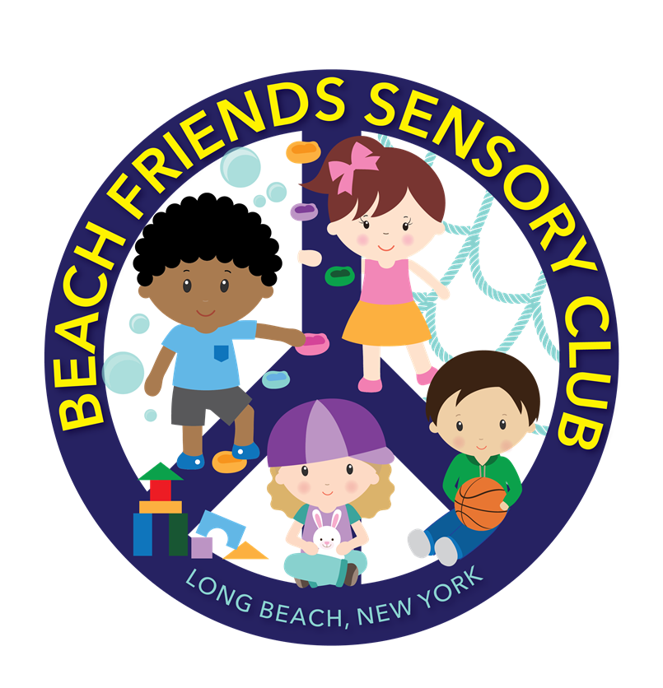

Name: ___________________________Date: ___________________________

Beach Friends Sensory Club Registration Check List
1) Emergency Procedure Acknowledgment/Sick Policy/No medication/Release
number___
2) Diaper Prep Consent/Photo Consent/Food consent _____
3) Schedule/Payment Agreement/Signatures of received documents___
4) Child Profile______
5) COVID-19 policies_______
6) COVID waiver______
7) Non-Medication Consent___
Diaper Rash _______
8) Child in Care Medical statement___
9) Copy of Handbook______
10) Registration fee_____
11) Security Deposit_____
Start Date____________
Birthday___________
End Date___________
Medical Due_________
Medical Due _________
Medical Due __________
Medical Due __________

Notes: _____________________________________________________________

Emergency Procedures Acknowledgement
I understand Beach Friends Sensory Club will take appropriate measures when dealing with injuries that occur while in the daycare. I agree that I will not hold Beach Friends Sensory Club responsible or any staff responsible for accidental injuries that occur during play activities in which children might engage. Suppose Beach Friends Sensory Club cannot contact parents and/or emergency persons listed on the Emergency and Release Persons Form. In that case, I hereby give permission to Beach Friends Sensory Club to secure the proper treatment for the child in a hospital given licensed and trained staff as needed.
*If a child becomes injured, parents will be notified immediately. An accident report will be written up and signed by staff. *
X_________________________________________ (Parent Signature)
_____________________________________ (Date)
Sick Policy
Beach Friends Sensory club will only allow well children in their program. Well children are non-sick children who have no symptoms of any minor childhood illness, and that does not represent a risk to other children. If a child becomes sick, a doctor's note is needed to return to Beach Friends Sensory Club.
X_________________________________________ (Parent Signature)
_____________________________________ (Date)
No Medication Policy
The staff can administer no medications at Beach Friends Sensory Club. I understand that I will be notified shall my child become ill during the day. I will pick up my child promptly or decide for an authorized emergency contact/release person to pick up my child upon such notification. If my child is exposed to or contact a contagious disease, I agree to notify Beach Friends Sensory Club, and I understand that my child will be readmitted once cleared by a doctor with a doctor's note.

Release of Phone Number/E-Mail Address
Beach Friends Sensory Club will send out a class list. Please consent to have your phone number and/or e-mail address released amongst families for possible play dates, birthday parties, etc.
____I consent
____I do not consent
phone number__________________ e-mail address____________________________
X____________________________________ (Parent signature)
__________________________________(Date)
Diaper Change Consent/External Preparations Consent
I hereby grant the permission that Beach Friends Sensory Club provider and staff can provide care by cleaning and changing my child as needed.
X____________________________ (Parent’s signature/Date)

I hereby permit Beach Friends Sensory Club to apply one or more of the following external preparations in accordance with the directions for use on the container; Baby wipes, Bandages, Neosporin, Hydrocortisone, Bacitracin or similar first Aid Sprays, Non-Prescription Ointments such as A and D and sunscreens.
No medications can be administered by Beach Friends Sensory club and its staff. I understand that I will be notified shall my child become ill during the day, and I will pick up my child promptly or decide for an authorized emergency contact/release person to pick up my child upon such notification.
Contagious Disease
If my child is exposed to or contracts a contagious disease, I agree to notify Beach Friends, and I understand that my child will be readmitted once cleared by a doctor provided with a doctor's note.
X____________________________ (Parent’s signature/Date)

Photo Consent

I hereby consent to give permission to Beach Friends Sensory Club to photograph, film or videotape my child ________________________. While at the daycare for educational purposes, communication between parents/staff and to promote our school.

X____________________________________
(Parent’s signature/Date)

Food Consent
I consent to allow my child to participate in cooking classes, birthday parties and consume foods outside of packed lunches.

X____________________________________________
(Parent’s signature/Date)

Infant Feeding ONLY

6 week-18 months
• All Bottles, cups, and utensils must be labeled with the child's full name. Powered formula, ready to feed milk, juice, and breast milk, must be pre-measured and labeled with the child's first and last name and expiration date.
• Children 6 months of age and under must be held during all bottle feedings.
• Microwave heating of infant food and formula is prohibited by regulation.
• The provider will make every effort to accommodate the needs of a child who
is breastfed.
Infants’ Name: _______________________
Date of Birth: _______________________
___I will provide all formula, solid food, water, and juice for my child.
Check all that apply:
___Breast Milk
___Formula-Brand________________
___Solid Foods
List of any food allergies:
______________________________________________
Please initial:
___I give the provider permission to add warm sterilized water to powered
formula.
___I give the provider permission to warm milk in a bottle warmer.
___I give the provider permission to warm solid food.
Please feed my infant according to the following schedule:
Signature of Guardian: ____________________ Date:
Signature of Provider: _____________________________ Date:

SCHEDULE AGREEMENT
SECURITY DEPOSIT: __________________ (2 weeks)
AMOUNT: ______________Paid on: ___________VIA: ________
REGISTRATION FEE: _________Paid on: ___________VIA: ________

START DATE: ______
It is hereby between______________ (Parent’s name) and Beach Friends Sensory Club that the following schedule will be available for _______________ (Child’s name) commencing on ________ (Date). I agree that I am responsible in the payment of the amount of $_______.00 each Monday or $__________.00 Monthly.
Monday_______ Time: ______
Tuesday_______ Time: ______
Wednesday____ Time: ______
Thursday______ Time: _______
Friday________ Time: _______
X_____________________________ (Parent’s signature/date)
PAYMENT AGREEMENT
I AGREE TO PAY A ONE-TIME REGISTRATION, NON-REFUNDABLE FEE OF $75.00. I AGREE THAT THE REGISTRATION FEE OF $75.00 WILL BE PAID IN FULL BEFORE ENROLLMENT. NOTE: THIS IS A ONE-TIME FEE ONLY. I AGREE TO PAY A 2 WEEK SECURITY DEPOSIT BEFORE ENROLLMENT (2 WEEKS PAYMENT OF SCHEDULED DAYS) OF $ _________ TO ENROLL MY CHILD. THE SECURITY DEPOSIT WILL BE RETURNED ONCE MY CHILD IS NO LONGER ENROLLED OR USED TOWARDS MY LAST TWO WEEKS OF CARE. I AGREE PAYMENTS ARE DUE MONTHLY PAYMENTS IN THE AMOUNT OF $__________. I AGREE CARE IS GIVEN AND PAID ON A MONTH-TO-MONTH BASIS. I AGREE I WILL NOT LEAVE IN THE MIDDLE OF THE MONTH AND/OR BEFORE OR AFTER HOLIDAY BREAKS/SCHOOL VACATIONS/PERSONAL VACATIONS AND/OR SICKNESS. I AGREE I WILL BE RESPONSIBLE TO PAY A FULL MONTH, AND PAYING WEEKLY IS A COURTESY. I AGREE TO PAY THIS AMOUNT IN FULL REGARDLESS OF PERSONAL VACATION TIME, SCHOOL VACATION TIME, OCCASIONAL SICKNESS, OR ANY OTHER REASON, SUCH AS A NATURAL DISASTER/ACTS OF GOD, STATE LOCKDOWN, PUBLIC HEALTH EMERGENCY, OR ANY OTHER UNFORESEEN CIRCUMSTANCES.
I UNDERSTAND NO ALLOWANCES, CREDITS, REFUNDS, AND MAKEUPS SHALL BE MADE FOR OCCASIONAL ABSENCES. I AGREE A LATE FEE OF $30.00 WILL BE CHARGED IF PAYMENT IS NOT RECEIVED FOR EACH DAY UNPAID. I AGREE AND UNDERSTAND THAT IF MY ACCOUNT IS DELINQUENT FOR MORE THAN 2 WEEKS, I MAY BE ASKED TO WITHDRAW MY CHILD UNTIL THE ACCOUNT IS MADE CURRENT. I AGREE THAT MY CHILD'S SPOT MAY OR MAY NOT BE HELD WHEN A CHILD IS WITHDRAWN. I AGREE MY CHILD WILL NOT BE ABLE TO RE-ENROLL IF A 2 WEEK NOTICE WAS NOT GIVEN OR IF MY ACCOUNT IS NOT CURRENT. I AGREE THAT ANY UNPAID FEES MAY BE SENT TO A THIRD-PARTY COLLECTION AGENCY. I AGREE MY SECURITY DEPOSIT WILL BE HELD IF THE TERMS ARE NOT FOLLOWED. I AGREE TO PAY A $50.00 SERVICE FEE FOR ALL CHECKS RETURNED BY THE BANK. I AGREE THAT IF I PICK UP MY CHILD AFTER SCHEDULED CLOSING, I WILL BE CHARGED A LATE FEE OF $1.00 PER MINUTE THAT I AM LATE UNTIL MY CHILD IS PICKED UP. I UNDERSTAND THAT IF MY CHILD ATTENDS FULL TIME, A TEN PERCENT DISCOUNT IS OFFERED FOR EACH ADDITIONAL CHILD FROM THE IMMEDIATE FAMILY. I UNDERSTAND THAT I MUST PROVIDE A 2 WEEK WRITTEN NOTICE OF WITHDRAWAL OR CHANGE OF SCHEDULE/CHANGE OF CONTRACT ALONG WITH 2 WEEKS PAYMENT FOR SCHEDULED DAYS FOR THE TWO WEEKS. I UNDERSTAND, THE DIRECTOR WILL PROVIDE A 2 WEEK DEPARTURE NOTICE AFTER THE TWO WEEKS IF MY CHILD IS WITHDRAWN. I UNDERSTAND THAT IF MY CHILD IS WITHDRAWN, THE CHILD WILL ONLY BE ELIGIBLE FOR READMISSION BASED UPON SPACE AVAILABILITY. BY SIGNING BELOW, I AGREE TO THESE TERMS.
I, ____________________________understand these terms listed above.
X________________________________________________________________
(Parent’s Signature)
I understand by signing the schedule agreement that my admission date is the date
my child will be enrolled.
X________________________ (PARENT’S SIGNATURE/DATE)

RECEIVED DOCUMENTS
I hereby agree and understand that I have received the necessary documents, including a copy of the daily schedule, behavior management plan, and evacuation plan.
X____________________________ (PARENT’S SIGNATURE/DATE)

CHILD PROFILE:
Name: ___________________________________________
Date: ____________________________________________
Parent’s Occupation:
Mom: ______________________
Dad: _______________________
What would you like most for your child to experience with us?

What does your child enjoy doing the most?

What are your child's favorite toys?

With whom does your child reside?

What language is spoken at home?

Please describe your child below. Please provide some additional information
about your child's family, your child's eating habits, sleeping habits, and any other
information.

COVID-19 POLICIES

1. Parents drop upstairs by gate only.
2. Children must wash hands upon arrival.
3. Health check will be done.
4. Please no outside toys at the daycare.
5. Parents will pick up by gate only.
6. Parents will socially distance themselves when entering the school.
7. If you suspect you are sick or tested for Covid-19, you must supply a clearance letter to the school.
8.Update medicals are required.

I, __________________ agree Beach Friends Sensory Club will not be
held responsible for any COVID-19 illnesses and I ______________ will bring my child________________ at my own will.

Emergency information
Name of Child: ____________________________
Date of Birth: _______________________
Gender: ___________________________
Address: __________________________
Contact: ___________________________
Email: _____________________________
Emergency Contact
Name: ____________________________
Contact: ___________________________
Email: _____________________________
Name: ____________________________
Contact: ___________________________
Email: _____________________________
Name: ____________________________
Contact: ___________________________
Email: _____________________________
Allergies: __________________________
Receiving services: _________________

