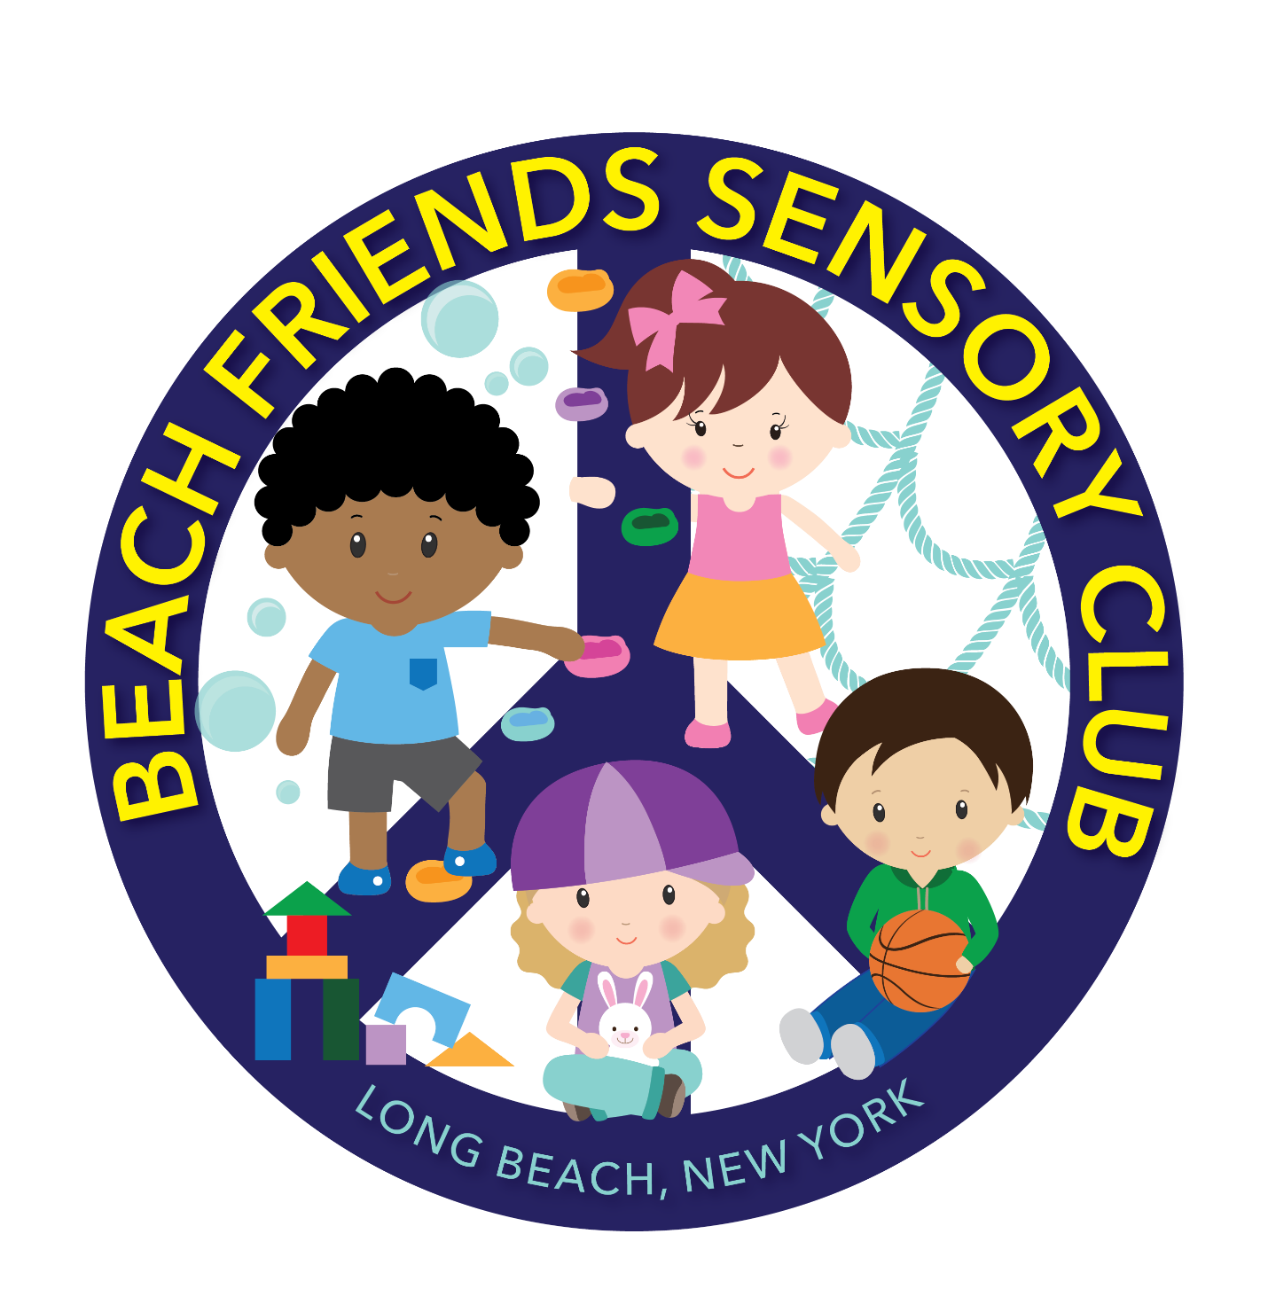

*SUBJECT TO CHANGE** (UPDATED May 5, 2021)
WELCOME TO BEACH FRIENDS SENSORY CLUB
HOURS: 8 am - 3 pm
DAYS: MONDAY-FRIDAY
LOCATION- 28 W PARK AVENUE, LONG BEACH NY 11561

DEAR FAMILIES,
WELCOME TO THE NEW SCHOOL YEAR! WE PROMISE TO HAVE ANOTHER FUN, EXCITING, SAFE, AND EDUCATIONAL SCHOOL YEAR AS WE CONTINUE OUR PARTNERSHIP, EMPHASIZING A COMMITMENT TO THE FINEST QUALITY OF EDUCATION. AS ALWAYS, OUR DIRECTOR, TEACHERS, THERAPISTS, AND STAFF ARE EAGER TO HELP EVERY STUDENT ACHIEVE SUCCESS. WE WILL CONTINUE TO MAKE GREAT EFFORTS TO CREATE A BEAUTIFUL, SAFE, AND NURTURING ENVIRONMENT WHERE OUR STUDENTS FEEL COMFORTABLE AND FEEL SAFE. DURING THE SCHOOL YEAR AHEAD, WE LOOK FORWARD TO WORKING TOGETHER AS A UNIT TO ACHIEVE AND MEET EVERY MILESTONE FOR YOUR CHILD. PLEASE REMEMBER THE MORE YOU ARE INVOLVED, THE MORE SUCCESS WE WILL HAVE TO PREPARE YOUR CHILD TO EXCEL IN THE FUTURE. IT TAKES A VILLAGE.
PROVIDER INFORMATION/QUALIFICATIONS
BEACH FRIENDS SENSORY CLUB ON-SITE DIRECTOR TIMOTHY KANHAI HAS A DEGREE IN EARLY CHILDHOOD DEVELOPMENT AND IS CURRENTLY COMPLETING HIS CHILD DEVELOPMENT ASSOCIATE (CDA) CERTIFICATE. TODAY TIMOTHY RESIDES IN LONG BEACH, NEW YORK, WITH HIS WIFE AND THREE CHILDREN.
OUR PHILOSOPHY AND RESPONSIBILITIES OF THE PROGRAM
OUR PHILOSOPHY IS ALIGNED WITH THE BEST PRACTICES ABOUT HOW CHILDREN LEARN AND GROW EFFECTIVELY WHILE ADDRESSING THE INDIVIDUAL NEEDS OF EACH CHILD. WE UNDERSTAND EACH CHILD IS UNIQUE, AND WE STRIVE TO LOOK AT THE WHOLE CHILD. WE CONCENTRATE ON THE FIVE DOMAINS, WHICH ARE LANGUAGE DEVELOPMENT, COGNITION, SOCIAL/EMOTIONAL, ADAPTIVE SKILLS, AND FINE/GROSS MOTOR SKILLS. OUR PROGRAM PROVIDES EARLY CHILD CARE. OUR PROGRAM IS CHILD-BASED AND INVOLVES FAMILIES THROUGHOUT THE PROCESS. WE WILL CONTINUE TO PROVIDE A POSITIVE ATTITUDE AND ENVIRONMENT FOR ALL PARTIES INVOLVED.
RESPONSIBILITIES OF THE FAMILIES
PLEASE REVIEW THE MANUAL AND ALL ITS PARTS TO ENSURE YOU EXPERIENCE A SMOOTH EXPERIENCE AT BEACH FRIENDS SENSORY CLUB. BE SURE TO BE AN ACTIVE PARTICIPANT ON THE HIMAMA APP.
ADMISSIONS, CHANGE OF SCHEDULE AND DISENROLLMENT
THERE WILL BE NECESSARY PAPERWORK TO COMPLETE BEFORE ENROLLING YOUR CHILD. PLEASE NOTE WHEN CHANGING YOUR CHILD'S SCHEDULE OR DISENROLLING YOUR CHILD, WE REQUIRE A 2 WEEK NOTICE. PLEASE SEE YOUR CONTRACT AND SCHEDULED AGREEMENT.
MISSION STATEMENT
BEACH FRIENDS SENSORY CLUB IS A 3 HOUR EARLY LEARNING PROGRAM SERVICING CHILDREN AGES 1-5 YEARS OLD. THE PROGRAM WILL NURTURE ALL CHILDREN WITH AND WITHOUT SPECIAL NEEDS IN A SAFE, INCLUSIVE, AND SUPPORTIVE ENVIRONMENT THROUGH EDUCATION, THERAPEUTIC INTERVENTION COMMUNITY ACCEPTANCE.

PROVIDER/STAFF HELPERS
BEACH FRIENDS SENSORY CLUB PRIDES ITSELF ON APPROPRIATE STAFFING, SAFETY, AND CLEANLINESS. ALL STAFF: BEEN FINGERPRINTED, PROVIDE REFERENCES, CLEARED THROUGH A NYS DATABASE, AND COMPLETED A CRIMINAL BACKGROUND CHECK. ALL STAFF MEMBERS ARE CPR, FIRST AID TRAINED, AND SERVE AS MANDATED REPORTERS (SEE BELOW).
MANDATED REPORTER
New York State is mandated to report any suspected child abuse or neglect. This means that Beach Friends Sensory Club has the legal responsibility to keep children safe and report any suspected abuse or neglect.
LIABILITY INSURANCE
Beach Friends Sensory Club carries private Business Liability Insurance through USAA.
SUBSTITUTES, ASSISTANTS, AND EMPLOYEES
Beach Friends Sensory Club will have one director at the site, headteachers who are CDA qualified, and assistants and substitutes when needed. These employees are qualified and trained employees who the New York State Office has approved of Children and Family Services. They, too, have specific qualifications and training needed to work with children and families. Staff meetings/formal and informal observations will be held and documented.
PRIVACY POLICY
1. Beach Friends Sensory Club shall respect and maintain the confidentiality of child/family records and any other information generated with individual child's services.
2. It is Beach Friends Sensory Club's legal and ethical responsibility to protect all educational records' privacy, confidentiality, and security.
3. Beach Friends Sensory Club shall make no voluntary disclosure of discussion, deliberations, and child/family records, except to persons authorized to receive it in the conduct of Beach Friends Sensory Club.
4. Beach Friends Sensory Club will do all that it can to protect your family's privacy and will abide by the state privacy law. Beach Friends Sensory Club will keep all records and information about your child and your family private and confidential unless the provider has written permission to reveal specific information.
Class-size and age groups
Mixed Groups, ages 1 – 5 years old
20 Children First Session (8 – 11 am) 20 Children First Session (9 – 12 pm)

DISCRIMINATION CLAUSE
Beach Friends Sensory Club will NOT discriminate against a client or child based on race, color, sex, disability, religion, or national origin. Beach Friends Sensory Club will not discriminate against a client or child based on marital status, sexual orientation, public assistance status, or any other factors.

CONTRACTS
Your contract will be renewed and reviewed EVERY August. Please sign and return promptly to ensure a guaranteed spot. Contracts are updated as you change your weekly schedule. A one-time registration fee is required. A security deposit in the amount of 2 weeks of care is also required.

COMMUNICATION
Communication is key!! Parent and teacher communication are essential components in the growth and progress of your child. We will communicate through extraordinary events, parent-teacher conferences, emails, phone calls, and the HiMama app. The HiMama app. is used as a means of communication with parents, caretakers, directors, therapists, and teachers. HiMama app will serve as a tool amongst all parties involved and give all parties involved the opportunity to express questions, comments, concerns, and suggestions. Also, it is a tool to explain the material we are learning in school so that it can be reinforced at home. This ensures home-school communication is being met. Also, please take out all papers in your child's folder and return the needed documents promptly. (Himama.com)

BEHAVIOR MANAGEMENT
Children may experience and show undesirable behaviors for a wide variety of reasons. These include: to escape/postpone an undesirable activity or event (i.e., task avoidance), to communicate, fear, frustration, or displease. A primary need (hunger, thirst), illness, to gain attention, to gain a tangible reward, to gain sensory feedback, to combat boredom, because they are overstimulated, out of habit, and/or to gain control of a situation (i.e., to gain power)
How do we manage these behaviors? We use sensory integration, planned to ignore, redirection, verbal cues, gestures, stickers, high fives, and verbal praise.
Sensory Integration can be incorporated into the daily routines of children who need sensory input to help organize their senses and decrease negative behaviors.
Planned to Ignore is when the teacher plans to ignore a behavior (if the behavior is not threatening to him/her or other students), not draw attention to the behavior. This is used mainly when a child is attention-seeking.
Redirection is used to help positively guide the child in hopes the child will follow a better direction in the classroom.
Verbal Cues, praise, and gestures help the children positively stay on task. Children love to be praised, so when appropriate behaviors are shown, stickers, high fives, and certificates will be used for rewards.
At Beach Friends Sensory Club, we prefer positive words versus negative words. For example, suppose a child is acting inappropriately and not following classroom rules or routines. In that case, we will praise the children who are "following" rather than single out the child or children who are not listening and not "following" classroom rules or routines. Let us try to stay away from negative attention! We strive to maintain a positive environment at Beach Friends Sensory Club!
RULES OF THE CLASSROOM
At Beach Friends Sensory Club, we will continue to enforce manners and appropriate behaviors. We expect everyone involved at Beach Friends Sensory Club to love and respect one another. We encourage and promote a positive environment. We enjoy and appreciate both positive and negative feedback respectfully.
ARRIVAL/DISMISSAL
Please refrain from dropping off your child after 15 minutes from class start time or picking your child up before 15 minutes before class ends. This becomes a distraction for both the child and the rest of the children/classroom. We work very hard to plan and organize special events for the children between those times.
Staff will sign in and out children every day.
Parents must write down any marks, bruises, or any new findings on their child or notify the director. Staff will perform a health check upon arrival. A staff member will document any findings at the start of care as well.
Children will not be released to anyone who is not on the emergency card. Your child will only be released to those designated on the emergency sheet.
*Please call/text if there is to be a change in dismissal arrangements.
Absent
Please contact the school to let them know when your child will be absent and expected to return to school.
BAD WEATHER CLOSING
Beach Friends Sensory Club will follow the Long Beach/Island Park Public Schools for decisions on school closing. If Long Beach/Island Park Schools close, then Beach Friends Sensory Club will close as well. During inclement weather, parents will be notified if the center will close. However, if Long Beach/Island Park Public Schools have a delayed opening, Beach Friends Sensory Club will most likely open at their regular time unless notified otherwise.

UPDATING RECORDS
The client's responsibility is to provide the provider with any necessary information about their child and update it as needed. This includes but is not limited to emergency contact information, immunization records, and a list of authorized people to pick up and drop off their child from the program. The blue emergency card is to be updated every time there shall be a change in information.

ILLNESS, HEALTH AND SAFETY POLICIES
Beach Friends Sensory Club will take appropriate measures when dealing with injuries that occur while in the daycare. You will agree that you will not hold Beach Friends Sensory Club responsible or any staff responsible in case of accidental injuries that occur during play activities in which children might engage in. Suppose Beach Friends Sensory Club cannot contact parents and/or emergency persons listed on the Emergency and Release Persons Form. In that case, you will hereby give permission to Beach Friends Sensory Club to secure the proper treatment for the child in a hospital given licensed and trained staff as needed. *If a child becomes injured, parents will be notified immediately. An accident report will be written up and signed by staff/provider.
Beach Friends Sensory Club will only allow well children in their program. Well children are non-sick children who have no symptoms of any minor childhood illness, and that does not represent a risk to other children. If a child becomes sick, a doctor's note of clearance is needed to return to Beach Friends Sensory Club. If we feel your child is unsafe or poses a risk to others, we will determine if your child can return for care regardless of clearance from the doctor.
If the child is absent for 3 or more consecutive days due to illness or injury, a physician's statement must be provided verifying the disability. Before returning to school from a sick leave of 10 calendar days or more, a child must provide a physician's verification that he or she may safely return to school. In any case, if you have a fever higher than 100. Degrees, you must provide a physician note.
If you suspect you may have symptoms of COVID-19 and/or have been tested for COVID-19, your child will not be able to return to school unless a COVID-19 clearance letter is given.
If there is a health crisis in the area, we will deal with school closings separate from Long Beach Schools.
EMERGENCY CONTACTS
CALL 911 IF THERE IS ANY EMERGENCY LOCAL POLICE STATION 859 E Park Avenue Long Beach, NY 11561 516-431-6868
LOCAL FIRE DEPARTMENT 1 W Chester Street Long Beach, NY 11561 516-431-2434
LOCAL EMERGENCY ROOM/HOSPITAL South Nassau Communities Hospital 325 E. Bay Drive Long Beach, NY 11561 877-768-8462
Communication with parents: In the event of an emergency which requires the program to evacuate, relocate, or shelter in place, parents will be notified as soon as possible. We would leave a notice on the door, call, use social media and email through the HiMama app.

CHILD NOT PICKED UP IN TIME POLICIES
Children not picked up at scheduled time will remain at the daycare until someone is able to safely pick up their child. If there is no communication, we will call 911. A late fee will be assessed for non-emergency-related lateness.

IMMUNIZATIONS
All children are required to have up-to-date immunization records. Please submit updated records when necessary. We will not enroll un-vaccinated children as per state laws; please discuss what is needed privately with the director.

TRANSPORTATION
There will be no transportation available by Beach FRIENDS SENSORY CLUB.

SMOKING AND DRINKING
We have zero-tolerance for smoking and drinking while children are in care.

MEDICATIONS
BEACH FRIENDS SENSORY CLUB administers absolutely NO medication.

ALLERGIES
Please inform the provider/staff of any allergies your child may have. The Blue card will have a section where you MUST list any allergies. Please update when changes need to be made. A copy of noted allergies will be posted inside the cabinet in the refrigerator.

CALENDAR
We follow the Long Beach/Island Park Public School Calendar. We will be open for summer camp in July and August.

BEACH FRIENDS SENSORY CLUB Calendar 2020-2021

September N/A - First Day of School for Beach Friends Sensory Club (school open)
September 28th-Yom Kippur (school closed)
October 12th-Columbus Day (school closed)
October N/A – Picture Day
November 3- Election Day (school closed)
November 11- Veteran's Day (school closed)
November 26th-27th- Thanksgiving Break (school closed)
December 24- January 4- Christmas Recess (school closed)
January 18 - Martin Luther King Jr. Day (school closed)
February 15th-19th President's Day (school closed)
March 24th- Picture Day (TBD) (school open)
March 29th-April 2nd Spring Recess (school closed)
May 28- May 31st-Memorial Day Recess (school closed)
June 30- Last Day of School/Report Cards (school open)
August 31st-September 8th Summer Recess (school closed)

*** Subject to change***

BEACH FRIENDS SENSORY CLUB Calendar 2021-2022

SEPTEMBER-JUNE
September 9th -First Day of School for Beach Family
September 16th -Yom Kippur (school closed)
October 11th -Columbus Day (school closed)
November 11th - Veteran’s Day (school closed)
November 25th and 26th - Thanksgiving Break (school closed)
December 24th - December 31st - Christmas Recess (school closed)
January 17th - Martin Luther King Jr. Day (school closed)
February 21st - 25th - President’s Day (school closed)
April 15th -22nd - Spring Recess (school closed)
May 30th Memorial Day Recess (school closed)
June 20th - Juneteenth (school closed)
June 24th - Last Day of School (school open)
JULY and AUGUST- SUMMER PROGRAM
June 27th - July 5th - Independence Day/Break (school closed)
August 29th -September 8th Summer Recess (school closed)
*** Subject to change***

NEWSLETTER
A calendar will be uploaded each month to keep you updated on our monthly curriculum, closed dates, field trips, cleaning days, staff meetings, picture day, report cards, family day, and other important information.

CURRICULUM
We use both traditional and non-traditional approaches to teaching at Beach Friends Sensory Club. Please be sure to view lessons that were learned in school and reinforce them at home. We believe in differentiated instruction across the board. Please see early learning guidelines at ocfs.ny.gov. As for Pre-k students, please see NYSED.gov for Pre-k State Standards.

DAILY SCHEDULE
Brief overview
½ hour – circle time (cognition)
½ hour – fine motor skills (OT)
½ hour – sensory gym/play (PT/social-emotional)
½ hour – Art and music
½ hour – self-help skills/snack time/cooking/science

FIELD TRIPS
Field trips will be held once a month at the school. A separate fee is required for field trips, and you may or may not choose to participate in these events. Field trips include but are not limited to art, music, face painting, science, baby sign language, clown and magicians, hoopla hoops/music, a trip to the library, baby yoga, and the exploration of animals

TOYS
Please refrain from having your children bring in toys from home. Personal toys can sometimes create conflicts between children, especially if another child damages or breaks a toy. We will have "Show and Tell," where specific dates and times will allow for your child to bring in their desired toys/things.

SHOW AND TELL
Show and Tell will be scheduled on certain days and times. Your teacher will inform you of those designated times. Show and tell is great! It gives children the opportunity to show off their favorite toy/thing. It is fun, and it promotes language and appropriate social interaction.

TOILET TRAINING/DIAPER CHANGING
Beach Friends Sensory Club will document each Urine/Bowel movement using a U and BM on our dry erase board located in our bathroom. Please ask a teacher to give you access to the board to viewing it when needed. Families, providers, and staff will work together to help your child to begin the potty-training process. If your child is in the process of potty training, please bring pull-ups with Velcro sides for easy changing. If your child is still in diapers, please provide diapers and wipes. Please remember, we cannot share the use of anyone's diapers. If your child does not have any diapers at the daycare, then a parent must supply them before dropping them off.
SUPPLIES
A list of needed supplies will be included in your registration packet. Please submit all supplies to your child's provider or in-site director promptly. These supplies are used throughout the year. The provider will request more supplies during the school year as needed.

School Supplies

1 Bookbag
1 Sippy cup
1 Folder
1 Marble notebook
1 Bagged snack (daily)
Diapers and wipes as needed diaper rash creams
6 Clorox wipes
4 Hand sanitizers
4 Tissue boxes
2 Size large box of gloves

CLOTHING
Extra clothing is used if a child has an accident and gets dirty or wet in an activity. Please make sure you bring back clean clothing to replace the soiled ones. Please remember that we cannot use another child's clothes, so please remember to replenish your child's extra clothes.

FOOD AND NUTRITION
Parents will be notified of unfinished food if it has become a pattern during snack time or suspect sickness/illness. We NEVER discard any leftover food as this is a means for you to understand and view your child's eating patterns at school. Parents will bring their snacks for their children every day. Please label, label, and label all containers, bottles, etc. We have about 50 different containers that come to and from school each day. We want to ensure all your personal belongings are NOT lost, misplaced, or placed in another child's snack bag. This ensures all your personal belongings are sent home each day. Parents should also have a water bottle for their child marked with their name, which will be returned at the end of the school day. We always like to keep the children hydrated throughout the day, especially in the summer months.
Please provide a separate bag with all and snacks, and the snack bag will be placed in a snack craft at the start of the day. Any food not in the snack bag will NOT be accounted for and assumed for non-day-care purposes.

PICTURE DAY
Picture day will be held in March and October.

FAMILY PICNIC
Beach Friends Sensory Club will host a party in June for families that are were previously enrolled and currently enrolled. This is a beautiful opportunity to meet and mingle with other moms/dads and families.

Social Media
Please visit us at Beach Friends Sensory Club, our social media platforms for pictures and weekly updates. Our primary communication is through the HiMama app.

COVID-19 POLICIES

WE WILL FOLLOW THE DEPARTMENT OF HEALTH-INTERMIX GUIDANCE FOR CHILD CARE DURING PUBLIC HEALTH EMERGENCIES. HERE ARE SOME OF BEACH FRIENDS SENSORY CLUB EXTRA PRECAUTIONS DURING THIS TIME.
1. CHILDREN AND STAFF MUST WASH HANDS OR USE HAND SANITIZER BEFORE
ENTERING DAYCARE.
2. A HEALTH CHECK IS PERFORMED DAILY.
3. PARENTS MUST SIGN A WAIVER THAT INDICATES THEY ARE RESPONSIBLE TO SCREEN
AND TEST THEIR CHILD EVERY DAY BEFORE THEY ENTER THE CENTER.
4. PARENTS, CHILDREN, AND STAFF WILL TRY AND SOCIAL DISTANCE WHEN NEEDED.
5. STAFF MUST WEAR A MASK EVERY DAY. CHILDREN MAY OR MAY NOT WEAR MASKS
INSIDE. WHEN ON A WALK OR IN PUBLIC, CHILDREN MUST WEAR MASKS.
6. STAFF MUST MAINTAIN A CLEANING LOG WITH DATES AND TIMES OF DESIGNATED
AREAS WHEN SANITIZED.
7. SHEETS WILL BE RETURNED DAILY, AND A CLEAN SHEET IS REQUIRED EVERY DAY.
8. FREQUENT HAND WASHING IS REQUIRED THROUGHOUT THE DAY.
9. UPDATED MEDICAL STATEMENTS ARE REQUIRED
10. BEACH FRIENDS SENSORY CLUB WILL SANITIZE TOYS SESSION.
11. A NEW STAFF AND CHILD LOG-IN SHEET WITH COVID CHECKLIST WILL BE USED.

BENEFITS and FEATURES of Beach Friends Sensory Club
• New (Enthusiasm, NO burnout, Willing to grow and learn)
• Professional Development and Credentials in relation to learning/curriculum
• Talents/background of staff
• Field trip every month
• Picture Day
• Special Events
• Daily updates and pictures via HiMama/Facebook page/Instagram
• Family owned and operated
• Small intimate setting
• Location/neighborhood
• Health: Nutrition/Mindfulness
• Safety: Natural Alternatives and Environmentally Responsibility
• Mixed Age Groups-kids learn from each other
• Regulations- Meet and Excel
*We are so excited for this upcoming year. We will always do our best to work efficiently with you and your child while creating an open line of communication always.
Please contact the on-site directors, Timothy Kanhai, if you have any questions, comments, and/or concerns. Thank you for choosing to be a part of the Beach Friends Sensory Club family. We believe in what we do and are confident that our program will benefit your child.
Love, Beach Friends Sensory Club
Beach Baby/Kids Daycare Price List
All sessions mixed ages
$55.00 a session $275 a week
Siblings receive a 10 percent discount.
One-time non-refundable Registration Fee: $75.00
Field trips are 1x a month which requires a separate fee. You may choose or not to participate in this activity.
Deposit is required and is based on the days your child is enrolled.

